**SARANPRATHICK.M**

**727721EUIT144**

**CC1**

**QUESTION 1:**

**package** pom.demo.demo;

**import** org.openqa.selenium.By;

**import** org.openqa.selenium.WebDriver;

**import** org.openqa.selenium.WebElement;

**import** org.openqa.selenium.chrome.ChromeDriver;

**import** org.openqa.selenium.chrome.ChromeOptions;

**import** io.github.bonigarcia.wdm.WebDriverManager;

**public** **class** q11 {

**public** **static** **void** main(String[] args) **throws** InterruptedException {

// **TODO** Auto-generated method stub

ChromeOptions co=**new** ChromeOptions();

co.addArguments ("--remote-allow-origins=*");

WebDriverManager.*chromedriver*().setup ();

WebDriver driver=**new** ChromeDriver(co);

driver.get ("https://www.saucedemo.com/");

driver.manage().window().maximize() ;

WebElement txtBoxl=driver.findElement(By.*xpath*("//*[@id=\"user-name\"]"));

txtBoxl.sendKeys("standard_user");

WebElement txtBox2=driver.findElement(By.*xpath*("//*[@id=\"password\"]"));

txtBox2.sendKeys("secret_sauce");

driver.findElement(By.*xpath*("//*[@id=\"login-button\"]")).click();

driver.findElement(By.*xpath*("//*[@id=\"add-to-cart-sauce-labs-backpack\"]")).click();

driver.findElement(By.*xpath*("//*[@id=\"shopping_cart_container\"]/a")).click();

driver.findElement(By.*xpath*("//*[@id=\"checkout\"]")).click();

WebElement txtBox3=driver.findElement(By.*xpath*("//*[@id=\"first-name\"]"));

txtBox3.sendKeys("SARANPRATHICK");

WebElement txtBox4=driver.findElement(By.*xpath*("//*[@id=\"last-name\"]"));

txtBox4.sendKeys("M");

WebElement txtBox5=driver.findElement(By.*xpath*("//*[@id=\"postal-code\"]"));

txtBox5.sendKeys("637212");

driver.findElement(By.*xpath*("//*[@id=\"continue\"]")).click();

String txt1=driver.findElement(By.*xpath*("//*[@id=\"item_4_title_link\"]/div")).getText();

System.***out***.println(txt1);

String txt2=driver.findElement(By.*xpath*("//*[@id=\"checkout_summary_container\"]/div/div[2]/div[8]")).getText();

System.***out***.println(txt2);

String currentTitle=driver.getTitle();

System.***out***.println(currentTitle);

String expectedTitle="Swag Labs";

**if**(currentTitle.equals(expectedTitle)) {

System.***out***.println("Title Matched");

}

**else** {

System.***out***.println("Title not Matched");

}

String currentUrl=driver.getCurrentUrl();

String expectedUrl="https://www.saucedemo.com/checkout-step-two.html";

**if**(currentUrl.equals(expectedUrl)) {

System.***out***.println("URL Matched");

}

**else** {

System.***out***.println("URL not Matched");

}

Thread.*sleep*(5000);

}

}

**OUTPUT:**

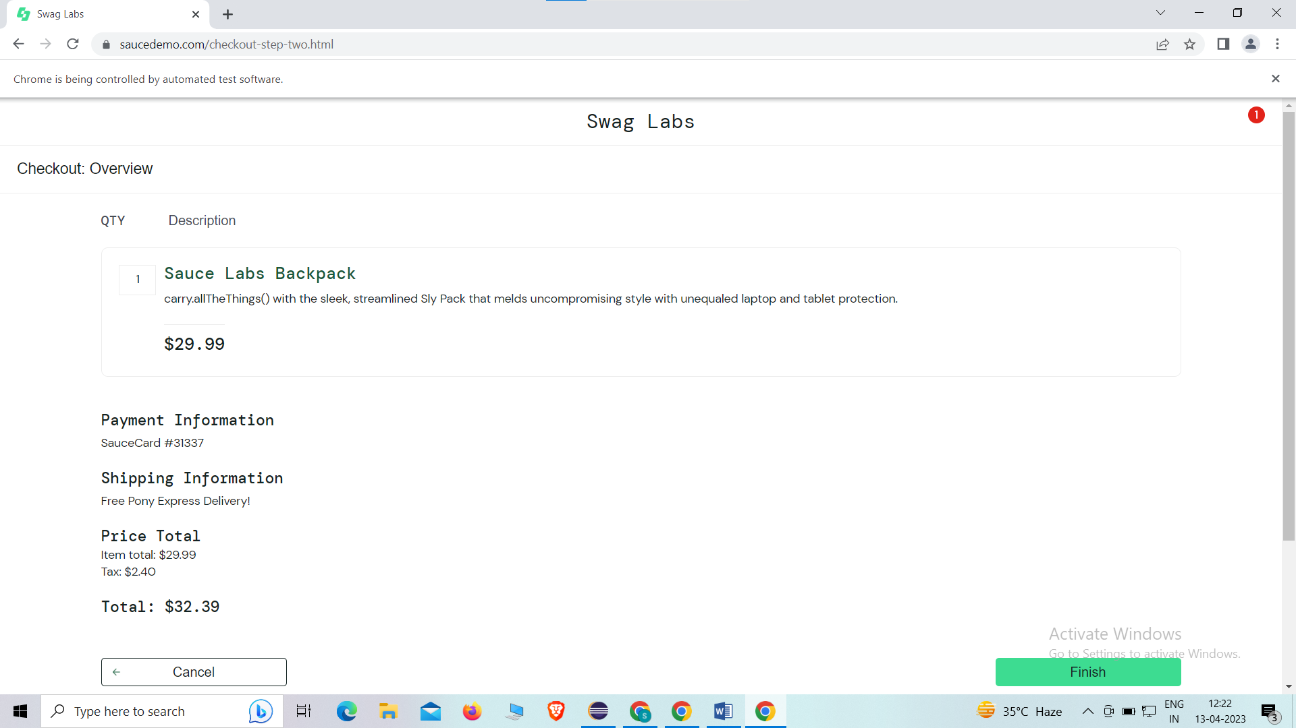

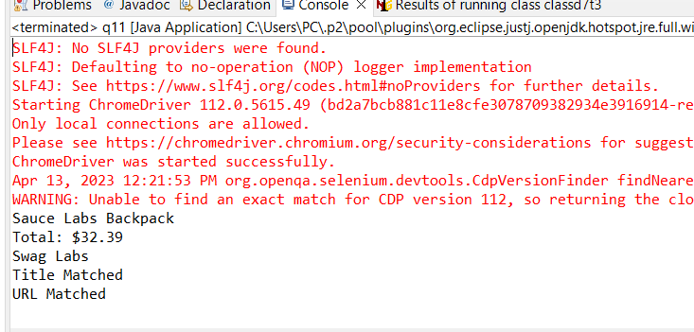

**QUESTION 2:**

**package** pom.demo.demo;

**import** org.openqa.selenium.By;

**import** org.openqa.selenium.WebDriver;

**import** org.openqa.selenium.WebElement;

**import** org.openqa.selenium.chrome.ChromeDriver;

**import** org.openqa.selenium.chrome.ChromeOptions;

**import** io.github.bonigarcia.wdm.WebDriverManager;

**public** **class** q22 {

**public** **static** **void** main(String[] args) **throws** InterruptedException {

// **TODO** Auto-generated method stub

ChromeOptions co=**new** ChromeOptions();

co.addArguments ("--remote-allow-origins=*");

WebDriverManager.*chromedriver*().setup ();

WebDriver driver=**new** ChromeDriver(co);

driver.get ("https://www.saucedemo.com/");

driver.manage().window().maximize() ;

WebElement txtBoxl=driver.findElement(By.*xpath*("//*[@id=\"user-name\"]"));

txtBoxl.sendKeys("standard_user");

WebElement txtBox2=driver.findElement(By.*xpath*("//*[@id=\"password\"]"));

txtBox2.sendKeys("secret_sauce");

driver.findElement(By.*xpath*("//*[@id=\"login-button\"]")).click();

String txt1=driver.findElement(By.*xpath*("//*[@id=\"item_4_title_link\"]/div")).getText();

System.***out***.println(txt1);

driver.findElement(By.*xpath*("//*[@id=\"header_container\"]/div[2]/div/span/select")).click();

driver.findElement(By.*xpath*("//*[@id=\"header_container\"]/div[2]/div/span/select/option[2]")).click();

String txt2=driver.findElement(By.*xpath*("//*[@id=\"item_3_title_link\"]/div")).getText();

System.***out***.println(txt2);

driver.findElement(By.*xpath*("//*[@id=\"header_container\"]/div[2]/div/span/select")).click();

driver.findElement(By.*xpath*("//*[@id=\"header_container\"]/div[2]/div/span/select/option[3]")).click();

String txt3=driver.findElement(By.*xpath*("//*[@id=\"item_2_title_link\"]/div")).getText();

System.***out***.println(txt3);

driver.findElement(By.*xpath*("//*[@id=\"header_container\"]/div[2]/div/span/select")).click();

driver.findElement(By.*xpath*("//*[@id=\"header_container\"]/div[2]/div/span/select/option[4]")).click();

String txt4=driver.findElement(By.*xpath*("//*[@id=\"item_5_title_link\"]/div")).getText();

System.***out***.println(txt4);

Thread.*sleep*(5000);

}

}

**OUTPUT:**

